**Data analysis of Prevalence of stroke in children admitted with sickle cell anaemia to Mulago Hospital using dplyr package in R Studio.**

Stroke is among the complications of sickle cell diseases that creates burden and steal childhood experience of children in East Africa. Understanding trends within data collected in health facilities can help to create good solutions to tackle this challenge.

Using data from from degratious Munube et al (hosted here <https://springernature.figshare.com/articles/dataset/Additional_file_1_of_Prevalence_of_stroke_in_children_admitted_with_sickle_cell_anaemia_to_Mulago_Hospital/4424036>)

I have used dplyr package in R Studio to find the following from the data provided.

1. More than 6% of all sickle cell disease patients admitted in a year were admitted with a primary diagnosis of stroke.

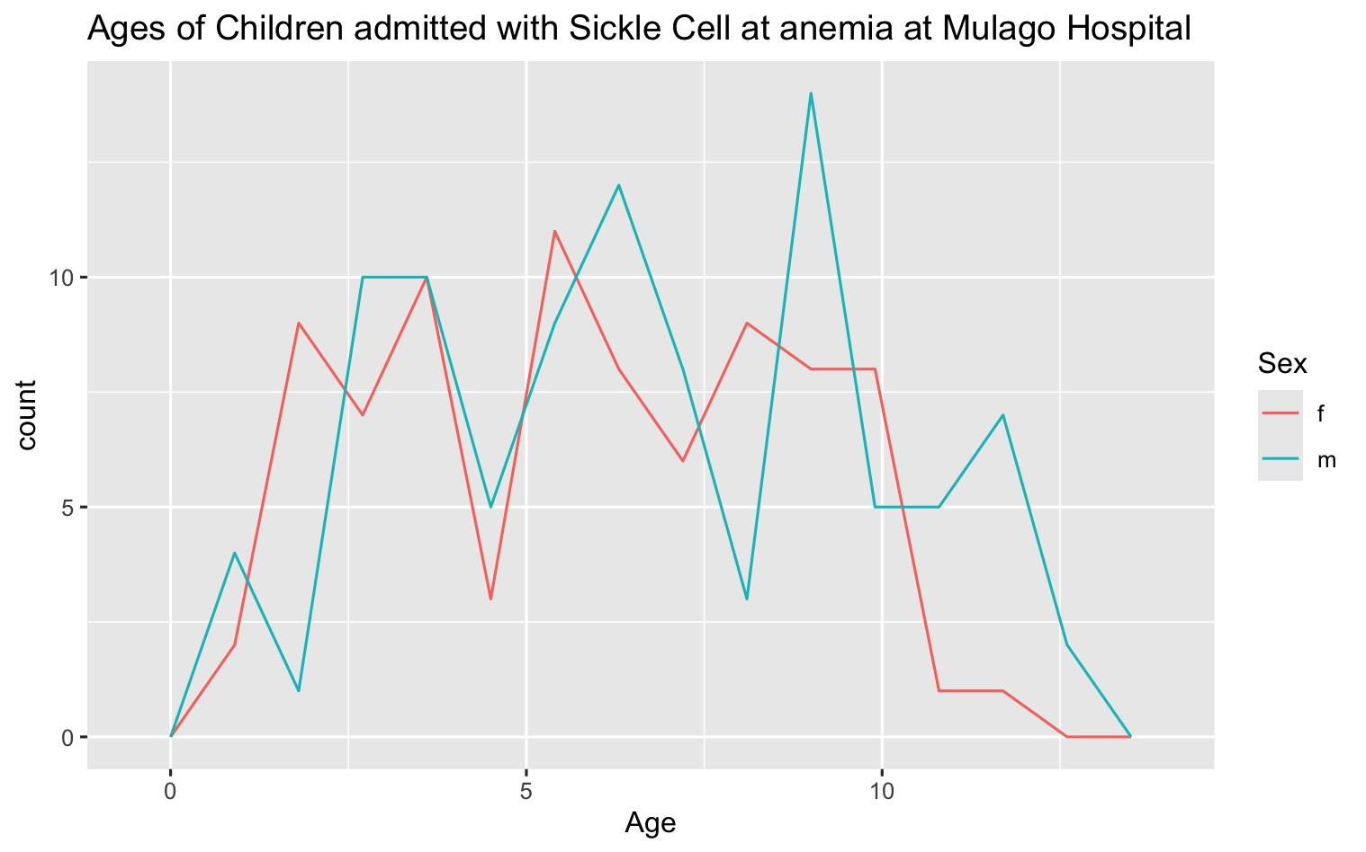

1. Of all the patients admitted 46.7% were females and 53.3% were males.
2. 58% of patients who had stroke also had secondary diagnoses of other health conditions that can also be life threatening such as acute chest syndrome, acute watery diarrhoea, pneumonia, severe malaria and septicaemia.
3. Interestingly, more than 28% of all patients who were admitted due to stroke also had severe anaemia.

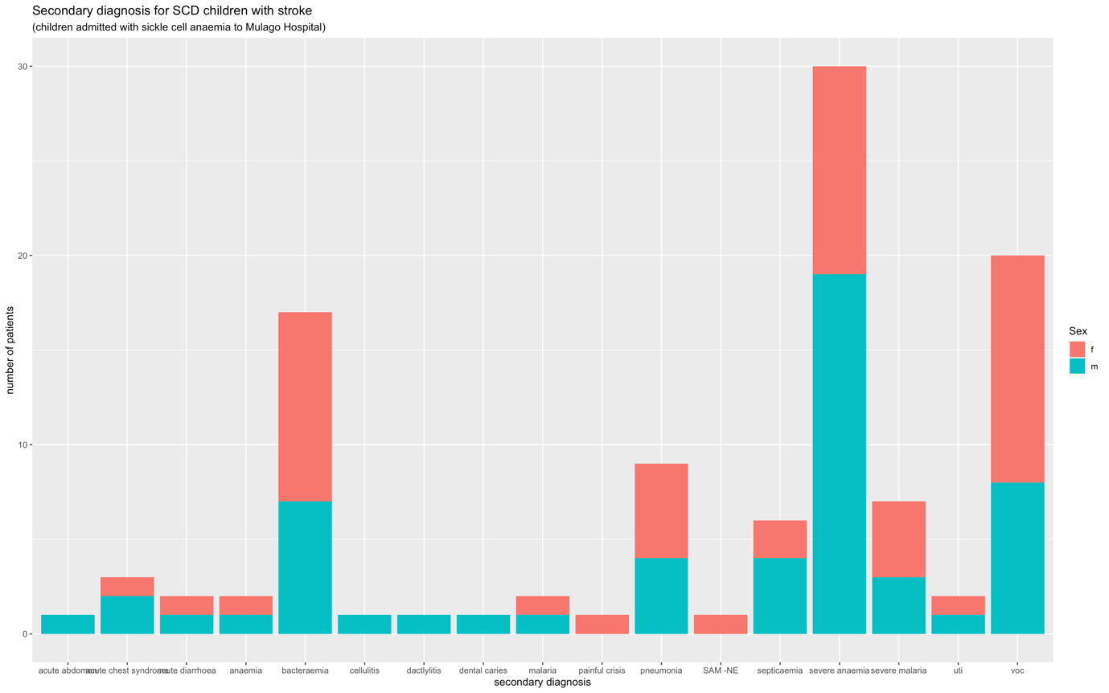

Data issues with the data set provided; By far this set was useful and insightful and a good working set for R training that is relevant with our environment. To add on this, further information like demographic information, methods of diagnosis, days of hospital stay and the likes could add further usefulness of this data set.

You can find my R script and analysis steps hosted in github here.